**Practical Exercise 1**

Create a html page as shown bellow

CreateProfile.html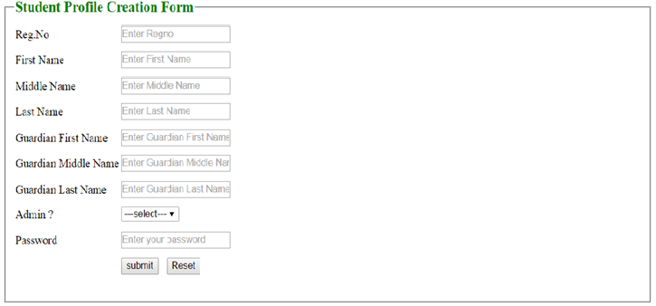

All above information should be mandatory.

Create the servlet which collects the all set of information from the form(createProfile.html) And stores it in to a database and generates the success or error message accordingly.

Success message 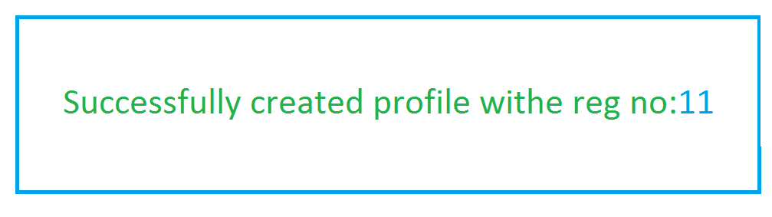

Error message

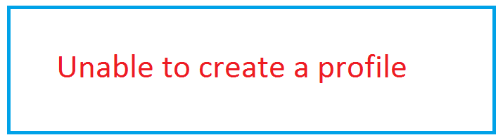

**Practical Exercise 2**

Create a html form as show bellow.

Search.html

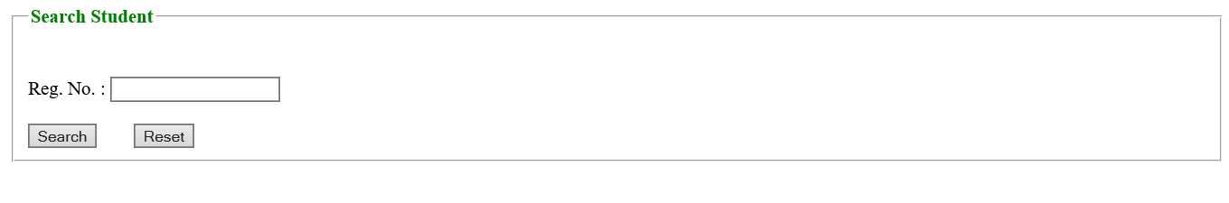

Create a servlet which takes the regno from the user (search.html) .

1. Check the regno in all 3 tables which we have in the database.
2. If regno is present, fetch the data from the tables(combination of data present in students_info, guardian_info and students_otherinfo) and print on the browser.
3. If regno is not present, print the error message on the browser.

Success message

|  |  |  |  |  |  |  |  |
| --- | --- | --- | --- | --- | --- | --- | --- |
| **Regano** | **firstname** | **midname** | **lastname** | **Gfirstname** | **Gmidname** | **Glastname** | **isadmin** |
| **1** | Praveen | N | D | D | N | A | Y |
|  |  |  |  |  |  |  |  |

Error message



**Practical Exercise 3**

Create the html page as shown bellow.

ChangePassword.html

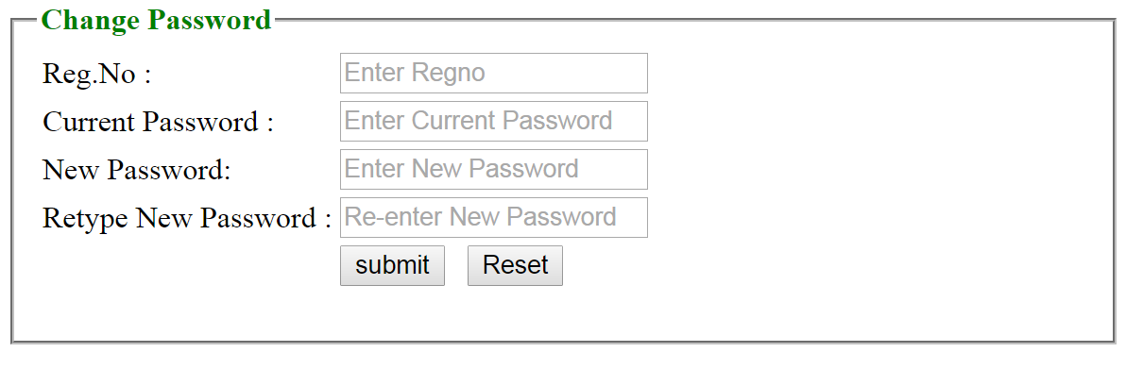

1. All data should be mandatory.
2. New password and Retype New password should match.

Create a servlet which takes the regno, old password, new password, retype New password from the user(changePassword.html).

1. This program should check new password and retype new password is matching or what.
2. If not matching print “new password & retype new password is not matching” on the browser.
3. If matching then should check whether the RegNo and password is correct in the database.
4. if Yes, then update the current password with new password,
5. if No then print the error message in the browser.

**Practical Exercise 4**

Create html page as show bellow.

Login.html

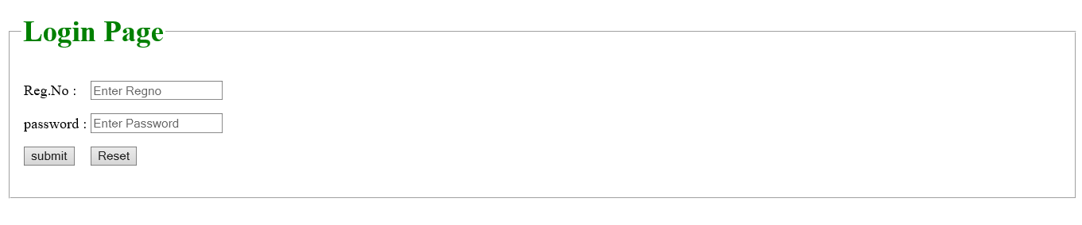

All data should be mandatory.

Create a servlet which takes regno and password from the user (login.html).

1. The program should check regno & password are correct.
2. If Yes then check whether that user in admin user or normal user

i) If admin user print as shown bellow.

ii) If normal user print his details

3. If No print the error message on the browser.

**Practical Exercise 5**

* Create html page as shown bellow.

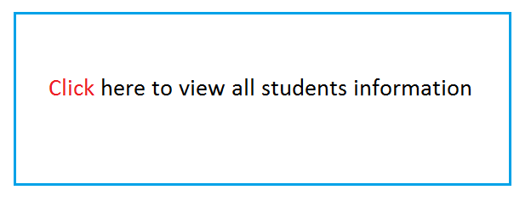Create a Servlet by name “ViewAllStudentsServlet” which gets the request from this Hyperlink and print all the student’s information in the browser.

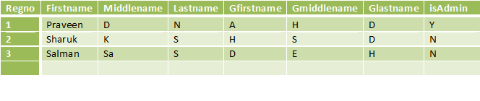

**Practical Exercise 6**

Create the html page as show bellow.

SearchItem.html

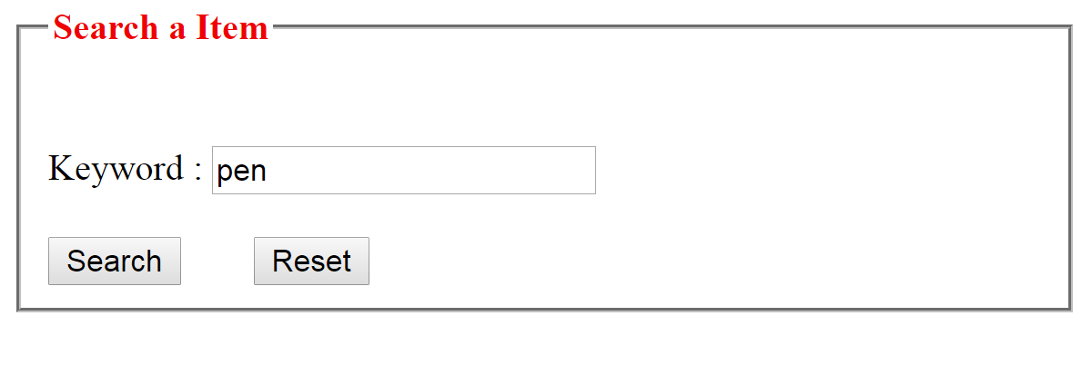

Create a servlet that takes input from the user (graingerSearch.html).

This program should take the input keyword from the user and that keyword is print on the [www.grainger.com](http://www.grainger.com/) web application search engine like bellow.

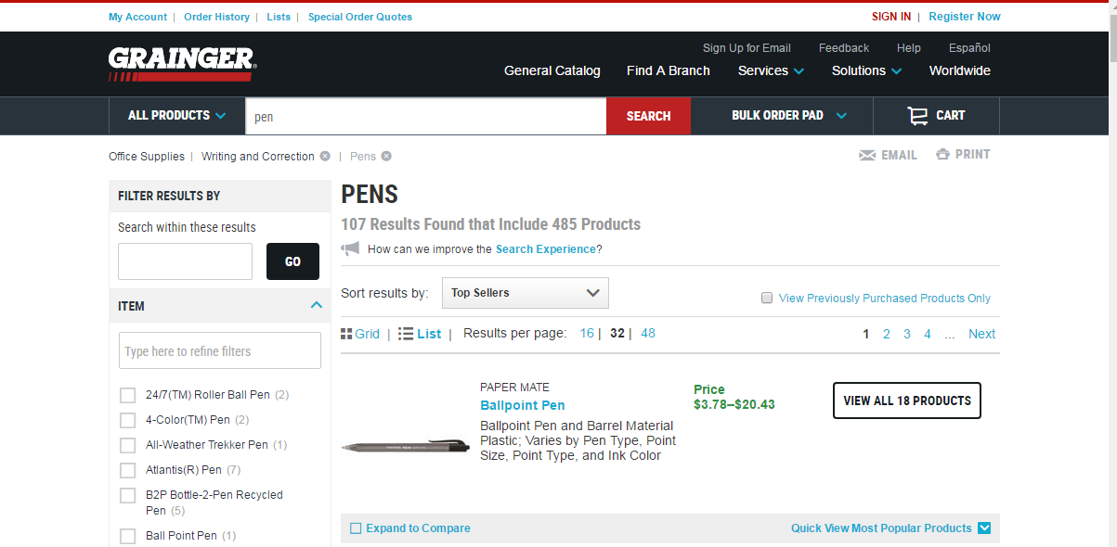

**Practical Exercise 7**